39.61: The time-dependent equation, with the separated form for 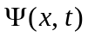 as given becomes
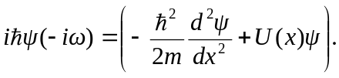
Since is a solution of the time-independent solution with energy 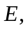 the term in parenthesis is 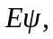 and so 